T4ToP
Training for Trainers of Phoenix

8 Short-term Discipleship Lessons.
Training Christ-followers to be Disciple-Makers

T4T is the process of disciple-making that was developed by Ying Kai and recorded by Steve Smith. For more information refer to the book T4T A Discipleship ReRevolution by Steve Smith with Ying Kai; WIGTake Resources, Monument, Colorado; 2011.


Phoenix Community of Atlanta, Inc. • Main Street NW Suite 400 • Duluth, GA 30097 Pastor Brian Holland • 770-884-1496 • bholland@phoenixatl.org
Pastor Jackie Fendley • 678-477-6560 • jackson@phoenixroasters.coffee

T4T Lesson Topics
The Purpose of These Lessons
The last thing Jesus commanded His followers to do was to make new disciples. We call this command "The Great Commission" (Matthew 28:18-20). Once a person becomes a follower of Jesus, they need to be equipped to obey Jesus' command to make disciples. Their own "house" is the first place to begin, but should spread to their friends and acquaintances. These lessons have been designed to be simple and transferable so that Christians can be trained in making disciples who are able to make disciples.

How to Make Disciples—An Overview of this Training
Becoming a spiritual baby is often used to describe the beginning of being born again. New parents dream of what their child will become and make plans. (Lesson 1) of disciple-making. When a spiritual baby is born, he has new life (Assurance of Eternal Life; Lesson 2). He needs to breathe (Prayer; Lesson 3), He needs to declare his new loyalty (Baptism Lesson 4), He needs to eat (Scripture Reading & Daily Devotions; Lesson 5), and he needs a family (The Church; Lesson 6). Then he needs to know who is in charge of the family (Our Heavenly Father; Lesson 7). Finally, he needs to get to work (Reaching Your World; Lesson 8).
Lesson | Trainer's Guide | Page
1 | Lesson 1 – The 3/3rds Discipleship Process . . . . . . . . . . . . . . . . . . . . . . . . . . . . . . . . . . . . . . . . . . . . . . . | 2
2 | Lesson 2—Assurance of Eternal Life . . . . . . . . . . . . . . . . . . . . . . . . . . . . . . . . . . . . . . . . . . . . . . . . . . . . . | 6
 | Lesson 2—Worksheet . . . . . . . . . . . . . . . . . . . . . . . . . . . . . . . . . . . . . . . . . . . . . . . . . . . . . . . . . | 8
3 | Lesson 3—Prayer . . . . . . . . . . . . . . . . . . . . . . . . . . . . . . . . . . . . . . . . . . . . . . . . . . . . . . . . . . . . . . . . . | 9
 | Lesson 3—Worksheet . . . . . . . . . . . . . . . . . . . . . . . . . . . . . . . . . . . . . . . . . . . . . . . . . . . . . . . . | 10
4 | Lesson 4 – Baptism . . . . . . . . . . . . . . . . . . . . . . . . . . . . . . . . . . . . . . . . . . . . . . . . . . . . . . . . . . . . . . . . | 11
 | Lesson 4 – Baptism FAQs . . . . . . . . . . . . . . . . . . . . . . . . . . . . . . . . . . . . . . . . . . . . . . . . . . . . . | 13
5 | Lesson 5—Bible Reading & Daily Devotions . . . . . . . . . . . . . . . . . . . . . . . . . . . . . . . . . . . . . . . . . . . . . | 15
 | Lesson 5—Worksheet . . . . . . . . . . . . . . . . . . . . . . . . . . . . . . . . . . . . . . . . . . . . . . . . . . . . . . . . | 17
6 | Lesson 6—The Church . . . . . . . . . . . . . . . . . . . . . . . . . . . . . . . . . . . . . . . . . . . . . . . . . . . . . . . . . . . . . . | 18
 | Lesson 6—Worksheet . . . . . . . . . . . . . . . . . . . . . . . . . . . . . . . . . . . . . . . . . . . . . . . . . . . . . . . . | 19
 | Lesson 6—Four Fields Diagram . . . . . . . . . . . . . . . . . . . . . . . . . . . . . . . . . . . . . . . . . . . . . . . . . | 22
7 | Lesson 7—Our Heavenly Father . . . . . . . . . . . . . . . . . . . . . . . . . . . . . . . . . . . . . . . . . . . . . . . . . . . . . . | 23
 | Lesson 7—Worksheet . . . . . . . . . . . . . . . . . . . . . . . . . . . . . . . . . . . . . . . . . . . . . . . . . . . . . . . . | 25
8 | Lesson 8—Reaching Your World . . . . . . . . . . . . . . . . . . . . . . . . . . . . . . . . . . . . . . . . . . . . . . . . . . . . . . | 27
 | Lesson 8—Worksheet . . . . . . . . . . . . . . . . . . . . . . . . . . . . . . . . . . . . . . . . . . . . . . . . . . . . . . . . | 28
 | Thru the Bible Overview . . . . . . . . . . . . . . . . . . . . . . . . . . . . . . . . . . . . . . . . . . . . . . . . . . . . . . . | 30
 | Bible Study Methods . . . . . . . . . . . . . . . . . . . . . . . . . . . . . . . . . . . . . . . . . . . . . . . . . . . . . . . . . . | 34
 | Gospel of Mark Overview . . . . . . . . . . . . . . . . . . . . . . . . . . . . . . . . . . . . . . . . . . . . . . . . . . . . . . | 35
 | Disciple Making Process Diagram . . . . . . . . . . . . . . . . . . . . . . . . . . . . . . . . . . . . . . . . . . . . . . . | 37
 | Ten Most Wanted Cards . . . . . . . . . . . . . . . . . . . . . . . . . . . . . . . . . . . . . . . . . . . . . . . . . . . . . . . | 38

Trainer's Guide to Lesson 1
"The 3/3rds Discipleship Process"

Desired Results for Trainees: Objectives are to define why the process is important to making disciples; to learn why we are to be about the process of making disciples; and to learn how to share the Gospel using “The Bridge”
Materials needed by the Trainer: Trainer’s Guide for Lesson #1; Worksheets for Lesson #1 for each trainee; blank sheets of paper for each trainee; Bible.

A note about the Three-Thirds Process
Ying Kai organized his training time into three parts. Each part comprised one-third of the time available for the meeting. For instance, if the meeting time was 60 minutes, then 20 minutes would be allocated for each part.

Reasons for the 3/3rds process:
- Discipleship is a relationship process.
- Many people who are not natural conversationalist.
- Many people are natural conversationalist.
- Time is valuable and limited.
- We, first and foremost, are interested in the people as people and not just as a means to an end; discipleship.

1st Third—Looking Back
7 min Pastoral Care—each person shares a highlight and challenge from this past week. 3 min Worship—share a scripture or song
7 min Accountability—How did you do in sharing Jesus and obeying what He said?
3 min Vision Cast—tell a story or make a point reminding everyone to make disciples who make disciples

2nd Third—Looking Up
20 min Lesson—Present the new lesson

3rd Third—Looking Onward
15 min Practice the Lesson—each trainee must practice the lesson so they can share it with others 5 min Fish & Follow—Each person shares something they will obey and someone they will tell

First Third of the Lesson—LOOKING BACK

Pastoral Care:
You will not do the Pastoral Care section this first session. Each group member will briefly introduce himself or herself.

Worship:
During each session include some form of worship such as singing, listening to a song, reading a Scripture, or sharing a devotional thought.
- “Our Father” - talk to God about how you can or can’t relate to the idea that He calls himself Our Father.

Vision-Casting:
Use this time each week to share stories, testimonies, and examples of how we can engage in fulfilling the Great Commission.

Making Disciples that Make Disciples (learn this story to be able to tell it to your trainees).
33 Another parable He spoke to them: “The kingdom of heaven is like leaven, which a woman took and hid in three measures of meal till it was all leavened.” Matthew 13:33

You, therefore, my son, be strong in the grace that is in Christ Jesus. ² And the things that you have heard from me among many witnesses, commit these to faithful men who will be able to teach others also. 2 Timothy 2:1-2

The letter in my chair.
The inspiration of Ying Chi.
October 2000, as Ying sat in CPM (Church Planting Movements) training, his eyes and mind were fixed on a poster in the room: “How many of my people will hear the gospel today?” Ying knew that ministry as he had practiced it was not sufficient to win the millions of lost in this new area. Something had to change. As he prayed and meditated, the Lord brought the Great Commission to Ying’s mind:
Then Jesus came to them and said, “All authority in heaven and on earth has been given to me. Therefore, go and make disciples of all nations, baptizing them in the name of the Father and of the Son and of the Holy Spirit, and teaching them to obey everything I have commanded you. And surely, I am with you always, to the very end of the age.” (Matthew 28:18–20)
The Lord gave Ying these insights:
- "Go, not come:" The Great Commission says we are to go, not invite people to come to us. We must go to where the lost are and train the new believers to also go to the lost, into factories, homes, shops and neighborhoods.
- "Everyone, not some:" We must make disciples of all, not just a few. We typically choose whom we want to share the gospel with, trying to pre-judge who might accept it. But God said for everyone to share with everyone. We cannot predict who will believe and whom God will use to birth a movement.
- "Make disciples, not church members:" We must not satisfy ourselves with making converts and church members. Jesus commanded much more. He wants true disciples. And what do true disciples do? They obey Jesus’ command to witness to others and train these new believers to do the same. So, every disciple must be a disciple-maker (trainer).
- "Baptized them:" as Ying thought on this, he realized that baptism is like a person's testimony, so he determined to train everyone to be able to share their faith story in 2 minutes or less.
- "Teach them:" these new disciples must be taught God's word and must be able to teach others also.
- "To obey:" Ying determined that a major shift must be made from "knowledge-based" discipleship to "obedience-based" discipleship. It is not enough to just know God's word, but we must obey it. The "three-thirds" process is a key part of teaching this shift to obedience.

Jesus promised that if we would do this, He would be with us always!

Through these insights a simple method of training disciples to train disciples emerged. He called this "Training for Trainers."

Now let's practice. What are the 6 key ideas (words) from the Great Commission that were used to develop the strategy of making disciples that make disciples? If we will do these six things, what did Jesus promise?

This is the purpose of these 8 lessons: to teach us WHY we should make disciples; to point out WHO we should begin to reach; and finally, HOW we can make disciples and train others to do the same.

So, the answer to WHY MAKE DISCIPLES? is very clear. Jesus commanded us to do so and promised that he would be with us to the end of the age.

22 So it was that the beggar died and was carried by the angels to Abraham’s bosom. The rich man also died and was buried. ²³ And being in torments in Hades, he lifted up his eyes and saw Abraham afar off, and Lazarus in his bosom.
24 “Then he cried and said, ‘Father Abraham, have mercy on me, and send Lazarus that he may dip the tip of his finger in water and cool my tongue; for I am tormented in this flame.’ ²⁵ But Abraham said, ‘Son, remember that in your lifetime you received your good things, and likewise Lazarus evil things; but now he is comforted and you are tormented. ²⁶ And besides all this, between us and you there is a great gulf fixed, so that those who want to pass from here to you cannot, nor can those from there pass to us.’ Luke 16

THE BRIDGE PRESENTATION
INSTRUCTIONS: | PRESENTATION:
Read Romans 6:23 | Let me share how we have assurance of eternal life… In the book of Romans chapter 6, verse 23, it says, “For the wages of sin is death, but the gift of God is eternal life in Christ Jesus our Lord.”
Draw lines to indicate a great canyon between God and man. Draw a stickman on one side and write “God” on the other. | You see, people are separated from God because of sin. It is as if we were on one side, and God was on the other side of a great canyon. What separates us from God is our sin. People have tried many ways to bridge the gap between themselves and God. They have tried good deeds, philosophy, even religion, but all of our efforts to bridge the gap fall short.
As you say it, write “wages,” “sin,” and “death” under the man. | The Bible says that what we have earned (wages) for being a sinner (sin) is death  (death). Death means more than just physical death—it means separation from God.
On God’s side of the canyon write “gift,” and “God” and “E. L.” | But this verse goes on to say that a gift (gift) has been provided by God (God), and this gift is eternal life (eternal life). On one side of the canyon we have wages and sin and death. And on the other side of the canyon, we have gift and God and eternal life.
 | - On which side of the canyon would you like to be?
Draw an arch bridge over the canyon, then draw a large cross between the two sides of the  canyon. | This is where the Bridge comes in. Jesus Christ is the Bridge that God has provided to give us the gift of eternal life. Through Jesus and His death on the cross to pay for our sins, we can cross over the canyon, and we will no longer be separated from God.
Write “Jesus” above the canyon; then draw an arrow through it. | This verse says that God provided the gift of eternal life in Jesus Christ. In order to cross over to God’s side of the canyon, we must go through Him. He is the Bridge!
 | To cross over a canyon on a bridge, you would have to trust the bridge to hold you. In the same way, in order to cross over to God, you must trust that Jesus Christ will be able to provide the way to eternal life.
 | - Does eternal life in relationship with God sound like something you would like to experience for yourself?
If they say, "Yes…" | Let’s pray and tell God you are willing to believe in Jesus Christ…
Lead them in a prayer to trust in  Christ. | (Help them put the Bridge in their own words as a prayer of repentance and belief.)

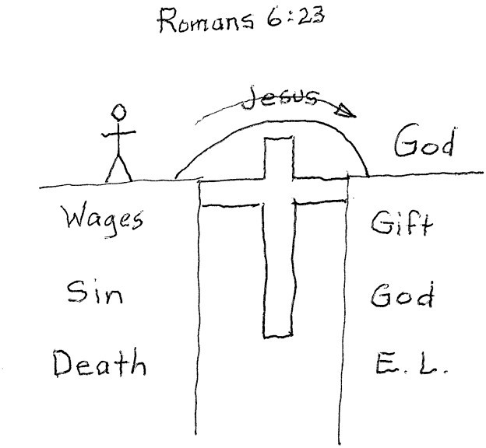

Here's what the finished picture should look like
The Bridge Illustration
https://www.youtube.com/watch?v=7d_k59S0Vxk https://www.youtube.com/watch?v=7gr0xXfR3L8

Accountability:
Next, we need to answer the question of "WHO should I talk to?" The answer is our family, friends, and those closest to us. The Bible word used to describe this group of people is the Greek word “OIKOS.”

Trainer's Guide to Lesson 2
"Assurance of Eternal Life"

Desired Results for Trainees: Objectives are to develop a Name List of people; to write their faith story; and to learn how to share the Gospel using “The Bridge”

Materials needed by the Trainer: Trainer’s Guide for Lesson #2; Worksheets for Lesson #2 for each trainee; “Ten Most Wanted” List; blank sheets of paper for each trainee; Bible.

First Third of the Lesson—LOOKING BACK

OVERVIEW OF THE "THREE-THIRDS PROCESS" (three-thirds refers to dividing your group time into three equal time periods)

First Third | Second Third | Final Third
- Pastoral Care  - Worship  - Accountability  - Vision-Casting | - New Lesson | - Practice  - Setting Goals & Prayer
LOOKING BACK LOOKING UP LOOKING ONWARD

Accountability:
Now, we need to answer the question of "WHO should I talk to?" The answer is our family, friends, and those closest to us. The Bible word used to describe this group of people is the Greek word “OIKOS.”

(Pick a few of these examples of God saving the person and their family from this list of Scriptures) Whenever God saved a person, He intends to save their whole family ("oikos"):
- Mark 5:18-20 – the Gerasene demoniac (especially verses 18-20) • John 4:39-42 – the Samaritan woman (especially verse 39)
- Acts 2:38-39 – the promise is for them and their children.
- Acts 10:24 – Cornelius along with his family and friends.
- Act 16:14-15 – Lydia and her household
- Acts 16:27-34 – Philippian jailer and his whole family.
- Acts 18: 8 – Crispus and his household.

Ask them to create a Name List of everyone they know who might be lost or far from God. Tell them to pray and ask God to bring to their minds who they should include on their list. Ask them to pray again and ask God who they should talk to first. Encourage them to identify 5 people they will share with first. Be sure to remind them to keep their list with them all week and to bring it with them to the next training session and be prepared to share their progress with others in the group.
VISION CASTING
19 Then He said to them, “Follow Me, and I will make you fishers of men.” Matthew 4:19

13 When Jesus came into the region of Caesarea Philippi, He asked His disciples, saying, “Who do men say that I, the Son of Man, am?”
14 So they said, “Some say John the Baptist, some Elijah, and others Jeremiah or one of the prophets.”
15 He said to them, “But who do you say that I am?”
16 Simon Peter answered and said, “You are the Christ, the Son of the living God.”
17 Jesus answered and said to him, “Blessed are you, Simon Bar-Jonah, for flesh and blood has not revealed this to you, but My Father who is in heaven. ¹⁸ And I also say to you that you are Peter, and on this
rock, I will build My church, and the gates of Hades shall not prevail against it. ¹⁹ And I will give you the keys of the kingdom of heaven, and whatever you bind on earth will be bound in heaven, and whatever you loose on earth will be loosed in heaven.” Matthew 16

Second and Final Third of the Lesson—LOOKING UP & ONWARD

(These two sections are combined for this this lesson)

New Lesson
During this part of the session, you will answer the last question of HOW do I start witnessing to others.

- FAITH STORY: Hand out worksheet and help them develop their Faith Story using the instructions on the sheet. When they have finished, have them practice sharing it with each other. Encourage them to give suggestions & feedback to each other.

Give Feedback to Each Other:
  - Eliminate anything that is confusing
  - Eliminate big Bible words
  - How can you make it more interesting?

- THE BRIDGE: Use reverse side of worksheet and work through The Bridge Gospel Presentation with them. Have them practice sharing it with someone.

Practice:
Have one or two people in each group explain the following:
- The 3/3rds process.
- The six key ideas / words of the Great Commission
- The concept of Name List
- How to write their Faith Story
- How to use the Bridge to share the Gospel

Set Goals:
  - Add to their Name List and pray for first group of 5
  - Revise their Faith Story and share with 5 friends
  - Practice using the Bridge to share the Gospel with 5 friends

Remind everyone that they will share their results next week during the Accountability time.

Close in Prayer

Worksheet for Lesson #2 My Personal Faith Story

My Personal Faith Story ("First Draft")—Name: Date:

- What my life was like before I trusted in Christ: In a word, how would you characterize your life before you began seriously following Jesus? Now write 2 or 3 sentences of explanation to describe this in more detail.

- When I decided to follow Jesus; what was happening that drew your attention to cause you to decide to follow Jesus? In a word, summarize what happened to get you to trust Jesus. Next, write 2 or 3 sentences of what happened when you decided to be a Christ follower. It might be something on the order of: “I realized I needed to ask Jesus to forgive my sins and take control of my life…” Provide a few details of what you experienced—where, when, how.

- What my life is like as a Christ-follower: In a word, how would you characterize the benefits of being a Christ-follower? Now explain this in more detail in 2 or 3 sentences. You are describing the benefits to you of being a Christian.

Trainer's Guide to Lesson #3
"Prayer"

Desired Results for Trainees: Objectives are to learn to pray or talk to God directly; what God invites you to talk to Him about; and to develop the habit being real, open, and transparent with God.
Materials needed by the Trainer: Trainer’s Guide for Lesson #3; Worksheet for Lesson #3; God’s Word.
First Third of the Lesson—LOOKING BACK

Pastoral Care: Ask the trainees to share a highlight & challenge from past week in bullet point form.
Worship: Share a time of worship by singing a song, reading a Psalm or giving a devotional thought.
Tell God what you think is different about living as His child in contrast to life before you received His love and forgiveness.
Accountability: This time is devoted to holding each other accountable to obey and serve God better. Challenge each other to obey whatever His word says. It is important to hold people accountable in two areas:
1) Sharing their faith story; and 2) Sharing the Bridge Illustration.

Vision-Casting
5 Spiritual Phases
8 Do not marvel that I said to you, ‘You must be born again.’ John 3:8
2 As newborn babes, desire the pure milk of the word, that you may
grow thereby, ³ if indeed you have tasted that the Lord is gracious. 1 Peter 2:2-3
Second Third of the Lesson—LOOKING UP

New Lesson:
- Jesus taught his followers to pray; anytime; always (without ceasing); often alone (see Mark 1:35; Matthew 14:23; Luke 5:16; 6:12).
- What are the 3 answers that God gives to our prayers? (Check all that apply) ☐ Yes ☐ No ☐ Wait
- Jesus taught his followers to pray to God/Yahweh as your Father in a private manner (Matthew 6:6).
- As you are doing the business/will of the Father you can get anything you need in the authority of the name of Jesus (John 14:13).
- Jesus puts his Holy Spirit in his followers, and he translate the Kingdom/business/will of the Father for us even when we do not know what to pray! (Romans 8:26-27)
- The Bible (Philippians 4:6-7) teaches us Prayer helps us overcome worry with thanksgiving; to overcome indecision with joy; and to overcome fear with peace.

Hand out the Worksheet #2 and work through a couple of the phrases with your trainees. Now have them complete the worksheet by recording their thoughts, questions, and actions; and by praying (talking with God) their way through the worksheet.
-9-

Worksheet for Lesson #3
“Prayer”

"Lord, teach us to pray!" The disciples asked Jesus this question. Here is what He taught them:
Our Father in heaven, Hallowed be Your name. Your kingdom come. Your will be done on earth as it is in heaven. Give us this day our daily bread. And forgive us our debts, as we forgive our debtors. And do not lead us into temptation but deliver us from the evil one. For Yours is the kingdom and the power and the glory forever. Amen. Matthew 6:9-13 (NKJV)

This is more of a revelation than a recipe.
Phrase | Thoughts, Questions, Actions
Our Father in heaven  Community/Equality | Jacob – the Almighty; Moses – “I Am”; Jesus said, “Call Him Abba, Father.”  More than meets the eye (standing, strength, status)
Hallowed be Your name | Respect and honor; pouring out sacrificial praises from our lips to God in Jesus’  name (Hebrews 13:15). Not for common use; “I do not take lightly the privilege to gather and pray in your name.” (reducing ruminations and self-criticisms)
Your kingdom come  Hope, power, participation | This is not about me and my desires. The purpose of prayer is to get to know the Father and partner with Him with my life.
Your will be done on earth as it is in heaven | What God wants from me for the kingdom business. (releases from burden of control; defines the goal/outcome of our faith/spiritual connection)
Give us this day our daily bread. (anti-worry) -------- | The Father will provide for his children every day if we acknowledge our dependence on Him. (reduces catastrophic future thinking)
And forgive us our debts, as we forgive our debtors. | The Father forgives us our sins against him and wants us to forgive others in the same way. (releases resentment; our response exposes God’s glory; reduces cortisol; recognizes God’s activity)
And do not lead us into  temptation but deliver us from the evil one. | The Father leads us and empowers us to resist the evil one. (keeps us aware and alerts us to differentiate other players unseen; boost courage and vision)
For Yours is the kingdom  and the power and the glory forever. Amen. | Please work through me; I am reporting for duty/service. (encases us in hope and humility, making anything possible for the glory of God)
Final Third of the Lesson—LOOKING ONWARD

Practice:
Have them discuss how we did Pastoral Care, Worship, and Accountability. Finally, ask them to explain how to teach someone to pray using the Lord's Prayer as a guide.

Set Goals & Pray:
- Remind them to obey this lesson by committing to pray each day.
- Set a goal to share your story to 5 people and to start training anyone who believes.

Close in Prayer -10-

Trainer's Guide to Lesson #4
"Baptism"

Desired Results for Trainees: Objectives are to learn why we follow Jesus by being baptized; what it means to be baptized, and when and how I baptize other new followers of Jesus.

Materials needed by the Trainer: Trainer’s Guide for Lesson #4; FAQ sheet on Baptism; and a Bible.
First Third of the Lesson—LOOKING BACK

Pastoral Care: Ask the trainees to share a highlight & challenge from past week in bullet point form.
Worship: Share a time of worship by singing a song, reading a Psalm or giving a devotional thought. Talk to God about the things that you think He is wanting you to do and ask Him to help you do them.
Accountability: This time is devoted to holding each other accountable to obey and serve God better. Challenge each other to obey whatever His word says. It is important to hold people accountable in two areas:
  - following Jesus; and 2) fishing for men (see Matthew 4:19). Here are the questions to ask this week.

Vision-Casting

FOLLOWING

“Follow me and I will make you fishers of men.” Matthew 4:19

    - How did you obey what God taught you from last week's lesson or your Scripture reading?
FISHING
    - Story: Who are you sharing your faith story with and/or demonstrating the Bridge Illustration to; and who has believed?
Second Third of the Lesson—LOOKING UP

New Lesson:
    - Starter: “We have a saying in this discipleship training, ‘As fishers of men, if you catch them, you clean them.’” If someone accepted Christ, have you started training them? Help them understand that they are to train them, not bring them back to this group.

When someone places their faith in Christ it is critical that before you leave them you teach them to share their faith with their family and friends by:
- Teaching them how to share their faith story
- Teaching them to share the Gospel using The Bridge
- Teaching them to obey by being baptized

In the Great Commission (Matthew 28:18-20) we are commanded to make disciples by "going," "baptizing," and "teaching to obey." Therefore, all disciple-makers should be "baptizers." You will need to teach the new disciples to obey by baptizing them as soon as possible after trusting in Christ.

Two questions answered:
- Why should new disciples be baptized?
- How do I baptize them?

Why be baptized?

Go through the Baptism FAQ Sheet and answer any questions. Announce a scheduled time for baptism in the event any need to be baptized and/or if they have someone they need to baptize.
Three reasons to be baptized (memorize these three reasons):
- Obey = baptism is an act of obedience. We are to be baptized because Jesus commanded it.
- Display = baptism is the way to display your faith in Christ. It tells others you have been saved.
- Portray = baptism portrays what happens when someone believes—they die to their old life and are raised to life as a monument to the victory of Jesus over death and evil. The water pictures the washing away of sin, (see Romans 6:3-4). We are ordained to be Ambassadors for Christ; (2 Corinthians 5:20)

How do I baptize them?
  - Locate water deep enough to immerse your new disciple (hot tub, bathtub, swimming pool, lake, etc.).
  - Have the new disciple invite their "oikos" (family, extended family & closest friends) to their baptism
  - Have the new disciple share their faith story (see Lesson 2)
  - You say, "I baptize you in the name of the Father, Son and Holy Spirit."
  - Lower them into the water and help them back up. It's just that simple.
Final Third of the Lesson—LOOKING ONWARD

Practice:
Have them explain the three-thirds process to each other and explain the 3 reasons to be baptized.

Stand someone beside a chair. Have the person hold their nose, sit down, lean back, then help them stand up again. (This is a close as you can get to what baptism is like without water.)

Set Goals:
Set a goal to share their faith story with 5 people on their list and to start training anyone who believes.

Close in Prayer

WHAT ABOUT MY CHILDREN?
ALLOW THEM TO BE BAPTIZED WHEN THEY TRUST IN JESUS: Since we believe the Bible teaches baptism is for those who have made a commitment to follow Christ, we wait until our children are old enough to believe and understand the true commitment they are making to Christ. Some churches practice infant baptism. This ceremony is intended to be a covenant between the parents and God on the behalf of the child. The parents promise to raise their child in the faith until the child is old enough to make his own personal commitment to Christ. While we affirm the idea of parents dedicating their children to the Lord, this is different from the baptism talked about in the Bible, which was only for those old enough to believe. The purpose of water baptism is to publicly confess and demonstrate your personal commitment to Christ.

Baptism FAQs:
Questions and Answers about Water Baptism for T4T Disciple Makers
I. WHY BE BAPTIZED?
To follow the example set by Jesus:
“At that time Jesus came from Nazareth and was baptized by John in the river.” Mark 1:9
Because Christ Commands it:
“Jesus said, ‘Go then to all people everywhere and make them my disciples, baptize them in the name of the Father, the Son, and the Holy Spirit…’” Matthew 28:19-20 (GNT)
It demonstrates that I really am a Believer:
“...many of the people who heard Him believed and were baptized.” Acts 18:8
“We know that we have come to know Him, if we obey His commands.” 1 John 2:3
II. WHAT IS THE MEANING OF BAPTISM?
It Is The Right Thing To Do (fulfill all righteousness)
¹³ Then Jesus came from Galilee to the Jordan to John, to be baptized by him. ¹⁴ John would have prevented him, saying, “I need to be baptized by you, and do you come to me?” ¹⁵ But Jesus answered him, “Let it be so now, for thus it is fitting for us to fulfill all righteousness.” Then he consented. ¹⁶ And when Jesus was baptized, immediately he went up from the water, and behold, the heavens were opened to him and he saw the Spirit of God descending like a dove and coming to rest on him; ¹⁷ and behold, a voice from heaven said, “This is my beloved Son, with whom I am well pleased.” Matthew 3:13–17
Baptism Connects Us With Christ (the Spirit of God descending like a dove and coming to rest on him)
And all who have been united with Christ in baptism have put on Christ, like putting on new clothes. Galatians 3:27
Or have you forgotten that when we were joined with Christ Jesus in baptism, we joined him in his death? For we died and were buried with Christ by baptism. And just as Christ was raised from the dead by the glorious power of the Father, now we also may live new lives. Romans 6:3–4
Obiedence Pleases The Father (“This is my beloved Son, with whom I am well pleased.”)
Note: Baptism doesn’t make you a believer—it shows that you already believe. It does not “save” you; only your faith in Christ does that. Baptism is like a wedding ring—it's the outward symbol of the commitment you made in your heart. “For it is by grace you have been saved, through faith...it is the gift of God—not by works, so that no one can boast.”
Ephesians 2:8-9
III. WHY BE BAPTIZED BY IMMERSION?

Because Jesus was baptized that way:

“As soon as Jesus was baptized, He went up out of the water.” Matthew 3:16
Every baptism in the Bible was by immersion:

“...then both Philip and the man went down into the water and Philip baptized him. When they came up out of the water...”
Acts 8:38-39
The word “Baptize” means “To Immerse” (the Greek word "baptizo" means to immerse or dip under water).
It best symbolizes a burial and resurrection:
For you were buried with Christ when you were baptized. And with him you were raised to new life because you trusted the mighty power of God, who raised Christ from the dead. Colossians 2:12

IV. WHO SHOULD BE BAPTIZED?
Everyone who has Believed in Christ:
“Those who believed and accepted His message were baptized.” Acts 2:41a
“But when they believed Philip as he preached the Good News…they were baptized, both men and women.” Acts 8:12
V. WHO CAN BAPTIZE?
Any Christ-follower who is connected with a local church:
Jesus' command in the Great Commission is as much a command to be baptizers as it is to be baptized.
“Go then to all people everywhere and make them my disciples, baptize them in the name of the Father, the Son, and the Holy Spirit, and then teach them to obey everything I have commanded you.” Matthew 28:19-20 (GNT)
VI. WHEN TO BE BAPTIZED?
As soon as you have believed: There is no reason to delay. Delayed obedience is disobedience. As soon as you have decided to receive Christ into your life, you can and should be baptized. If you wait until you are “perfect,” you’ll never feel “good enough." Acts 2:41 “Those who believed...were baptized...that day!”
“Then Philip began with the scripture and told him the Good News about Jesus. As they traveled along the road, they came to some water, and the man said, ‘Look, here is water! Why shouldn’t I be baptized right now?’ Philip said, ‘If you believe with all your heart, you may.’ The man answered, ‘I believe that Jesus Christ is the Son of God.’ So, they went down into the water and Philip baptized him.” Acts 8:35-38
VII. WHY IS BAPTISM IMPORTANT?
There is something very special that happens when a person is baptized. Often, we hear that it is one of the most profound spiritual experiences in a person’s life. This is because we are experiencing just a little of what Jesus experienced when he died on the cross for us. We have to be willing to humble ourselves and get wet in front of people. In this we share just a very small part of Christ’s suffering. We don’t want anyone to miss out on this experience.
"I want to know Christ and experience the mighty power that raised him from the dead. I want to suffer with him, sharing in his death" Philippians 3:10

HOW TO BAPTIZE
  - Baptism Instructions:
    - Baptize as soon as possible after a person trusts Christ—teaching immediate obedience
    - Have family members, friends or other witnesses present at the person's baptism
    - Connect them with a local congregation immediately
    - Keep Accurate Record of Baptisms
  - Possible Baptism Places: Swimming Pool; Hot Tub; Bathtub; YMCA; Health Club; Pickup-truck; Stock-tanks; Ponds; Rivers; Streams
  - What you should wear: Women should wear shorts and a dark t-shirt rather than a swimsuit. Men may wear a swimsuit and a dark t-shirt. Don't forget a towel and a change of clothes.
  - What to say during a baptism:
    - Ask the person being baptized to share their faith story.
    - Then baptize saying, "In obeying Jesus Christ and because of your confession of Him as your Savior and Lord, I baptize you (name), in the name of the Father, Son and Holy Spirit."

Trainer’s Guide for Lesson #5
"Bible Reading & Daily Devotions"
Desired Results for Trainees: Objectives are to learn new methods for reading and understanding the Bible; to compare & contrast different translations of the Bible; and to develop the habit of a personal time of devotion.

Materials needed by the Trainer: Trainer’s Guide for Lesson #5; Worksheet for Lesson #5; and a Bible; “Suggestions and Tool for Your Spiritual Life”
First Third of the Lesson—LOOKING BACK

Pastoral Care:
Ask each person to share with their group a highlight & challenge from the previous week and then have someone pray collectively for the group.

Worship:
During each session include some form of worship such as singing, listening to a song, reading a Scripture, or reading a devotional thought. Share a need you have with a partner or the group and pray together about your needs.

Accountability:
Explain to your trainees the vision of forming generations of trainers. Also tell them that Ying Kai classified people as: attendees; witnesses; starters; and trainers and our goal is to help people move from where they are to the next level.

FOLLOWING
      - How did you obey what God taught you from last week's lesson or your Scripture reading?

FISHING
      - Witness: Who are you witnessing to and who has believed?
      - Starter: If someone accepted Christ, have you started training them? Help them understand that they are to train them, not bring them back to this group.
      - Trainers: How are your new believers doing in sharing their faith stories and winning others?

Vision-Casting: "Turtles on a Fencepost"—an Illustration of the Holy Spirit's Power
Whenever you see a turtle sitting on a fencepost what can you deduce? Answer: He didn't get there by himself. Someone had to put him there. In the same way, no one is seeking God unless God is at work in their lives bringing them to Himself. Our job is to be alert for "turtles on a fencepost."

Romans 3:11 (NLT)
No one is truly wise; no one is seeking God.

John 6:44 (NLT)
For no one can come to me unless The Father, who sent me, draws them to me, and at the last day I will raise them up.

If the trainees are getting discouraged in their efforts, encourage them and remind them of who they can be in Christ. Explain the Holy Spirit’s Power. Encourage them to continue with their daily devotional time of prayer and reading the Bible, and to be faithful in sharing, but to allow the Holy Spirit to do His work in bringing people to Christ.
Second Third of the Lesson—LOOKING UP

New Lesson:
Hand out the Worksheet #5 and work through it with your trainees.
- Do a "Star Method" Bible study of Matthew 14:22-33
- Do a "3-Column Method" Bible study of Psalm 19:8
Final Third of the Lesson—LOOKING ONWARD

Practice:
Have them explain the three-thirds process to each other and then explain how to teach someone to use the Bible Study methods presented in this lesson.

Set Goals:
- Use one of these study methods in their daily Bible reading this week.
- Set a goal to witness to 5 people on their list and to start training anyone who believes.

Close in Prayer
Here is a partial list of Bible study tools available for free on the Internet.
  - YouVersion (www.youversion.com)
  - Bible Gateway (www.biblegateway.com)
  - Bible Study Tools (www.biblestudytools.com)
  - Glo Bible (www.globible.com)

Suggestions and Tools for Your Spiritual Life

2 Timothy 3:16–17 (NLT)
All Scripture is inspired by God and is useful to teach us what is true and to make us realize what is wrong in our lives. It corrects us when we are wrong and teaches us to do what is right. God uses it to prepare and equip his people to do every good work.

According to 2 Timothy 3:16-17, why is it so important to have a daily time with God's Word?
By the Word of God, we can know the truth and discover what is wrong or lacking in our lives. It gives us correction to instruct us in the right way of thinking and doing. It equips us to do every good work for the Father’s kingdom.
6 “And these words which I command you today shall be in your heart. ⁷ You shall teach them diligently to your children and shall talk of them when you sit in your house, when you walk by the way, when you lie down, and when you rise up. Deuteronomy 6

"And you shall remember all the ways the Lord your God has led you," Deuteronomy 8:2.

Worksheet for Lesson #5
"Bible Reading & Daily Devotions"

RECOMMENDED BIBLE STUDY METHOD
Here is a simple method that many have found to be very helpful in their study of the Scriptures. This method is especially helpful to people who are just beginning their Bible study and is effective for personal as well as group or one-on-one study.

I. "STAR METHOD"
- First, read the passage aloud. (Can take turns if in a group)
- Each person then reads back over the passage on their own and looks for these 3 things:
  - Anything that stands out or draws the attention of the reader. Mark these things with a Star. (★)
  - Anything that the reader finds hard to understand or has a question about. Mark these things with a Question Mark. (?)
  - Anything that applies personally to the reader’s life or that they feel directs them to do something. Mark these with an Arrow. (→)
- Each person should write down at least one thing, but no more than three, under each category.
- Each person should then share things they have marked with a Star and discuss them with the group. Everyone shares all their Stars first before you go on to the Question Marks.
- Each person should share things they have marked with a Question Mark and the group should try to work out answers for each. A core value is to never answer a question unless you answer it from the Scriptures. A perfectly acceptable answer is, "I don't know, but let's both look into this and see what we find out for next time."
- Each person should then share things they have marked with an Arrow and discuss them with the group.

Listen to the Bible verses below and use the STAR method to discuss.
Psalm 1:1-3; Blessed is the man
Who walks not in the counsel of the ungodly, Nor stands in the path of sinners,
Nor sits in the seat of the scornful;
2 But his delight is in the law of the Lord, And in His law he meditates day and night. 3 He shall be like a tree
Planted by the rivers of water,
That brings forth its fruit in its season, Whose leaf also shall not wither;
And whatever he does shall prosper.
Romans 15:4; For whatever things were written before were written for our learning, that we through the patience and comfort of the Scriptures might have hope.
Psalm 19:8 The statutes of the Lord are right, rejoicing the heart; The commandment of the Lord is pure, enlightening the eyes.
James 1:23-25 ²³ For if anyone is a hearer of the word and not a doer, he is like a man observing his natural face in a mirror; ²⁴ for he observes himself, goes away, and immediately forgets what kind of man he was.
25 But he who looks into the perfect law of liberty and continues in it and is not a forgetful hearer but a doer of the work, this one will be blessed in what he does.

What are the benefits of personal Bible study?

Trainer’s Guide for Lesson #6
“Church: Christian Community”
Desired Results for Trainees: Objectives are to identify and understand the essential functions of the church, and to learn how to gather new believers into groups that will experience these healthy church functions.
First Third of the Lesson—LOOKING BACK

Pastoral Care:
Have someone in the group(s) lead this portion of sharing highlights and challenges.

Worship:
Encourage trainees to partner with someone and pray for their expressed challenges.

Accountability:
Remind them of the vision to form generations of trainers. Use the diagram that illustrates how most groups turn inward instead of starting new groups. Point out that we have added a new level called Trainer of Trainers.

Accountability:
Explain to your trainees the wheel and that the life of the disciple maker is to help move people to take the next step in following Jesus and growing in the faith.
FOLLOWING
- How did you obey what God taught you from last week's lesson or your Scripture reading?
FISHING
- Witness: Who are you witnessing to and who has believed?
- Starter: If someone accepted Christ, have you started training them? Help them understand that they are to train them, not bring them back to this group.
- Trainers: How are your new believers doing in witnessing and winning others?
- Trainer of Trainers: Are they gathering people into groups and training them?

Vision-Casting:
Share the Four Fields diagram to illustrate how the process leads to church formation.
Second Third of the Lesson—LOOKING UP
Lesson: Hand out the worksheet #6 and work through the questions with them.
Note: When you become a Christian, you are a member of God’s family. God is your heavenly Father, and all Christians are like brothers and sisters of the same family. “…this household is the church of the living God…” (I Timothy 3:15). The household is not a building, and the “church” is not a place of worship, but is a body (a connected gathering) of believers.
Final Third of the Lesson—LOOKING ONWARD

Practice:
Have them partner with someone and practice teaching all of the parts, not just the new lesson.

Set Goals:
- To gather a few people together to start a group for either Bible study or to be trained.
- Set a goal to witness to 5 people on their list and to start training anyone who believes.

Close in Prayer -18-

Worksheet for Lesson #6
“Church: Christian Community”
Note: When you become a Christian, you are a member of God’s family. God is your heavenly Father, and all Christians are like brothers and sisters of the same family. “…this household is the church of the living God…” (I Timothy 3:15). The household is not a building, and the “church” is not a place of worship, but is a body (a connected gathering) of believers.

What are the essential elements of a church?
Acts 2:41–47 (NLT) Those who believed what Peter said were baptized and added to the church that day—about 3,000 in all. ⁴² All the believers devoted themselves to the apostles’ teaching, and to fellowship, and to sharing in meals (including the Lord’s Supper), and to prayer. ⁴³ A deep sense of awe came over them all, and the apostles performed many miraculous signs and wonders. ⁴⁴ And all the believers met together in one place and shared everything they had. ⁴⁵ They sold their property and possessions and shared the money with those in need. ⁴⁶ They worshiped together at the Temple each day, met in homes for the Lord’s Supper, and shared their meals with great joy and generosity— ⁴⁷ all the while praising God and enjoying the goodwill of all the people. And each day the Lord added to their fellowship those who were being saved.

We believe there are 9 key elements of a healthy, Biblical church. They are listed below:

Baptism The Bible Lord's Supper Care for One Another Giving Prayer
Worship Making Disciples Qualified Leaders
  - Pair with someone and read Acts 2:41-47 (above) and then find the 9 key elements that should characterize a healthy church derived from the Acts 2 passage.
  - The diagram below is a way to visualize these 9 elements. Use this diagram to explain Acts 2:41-47 to your partner:
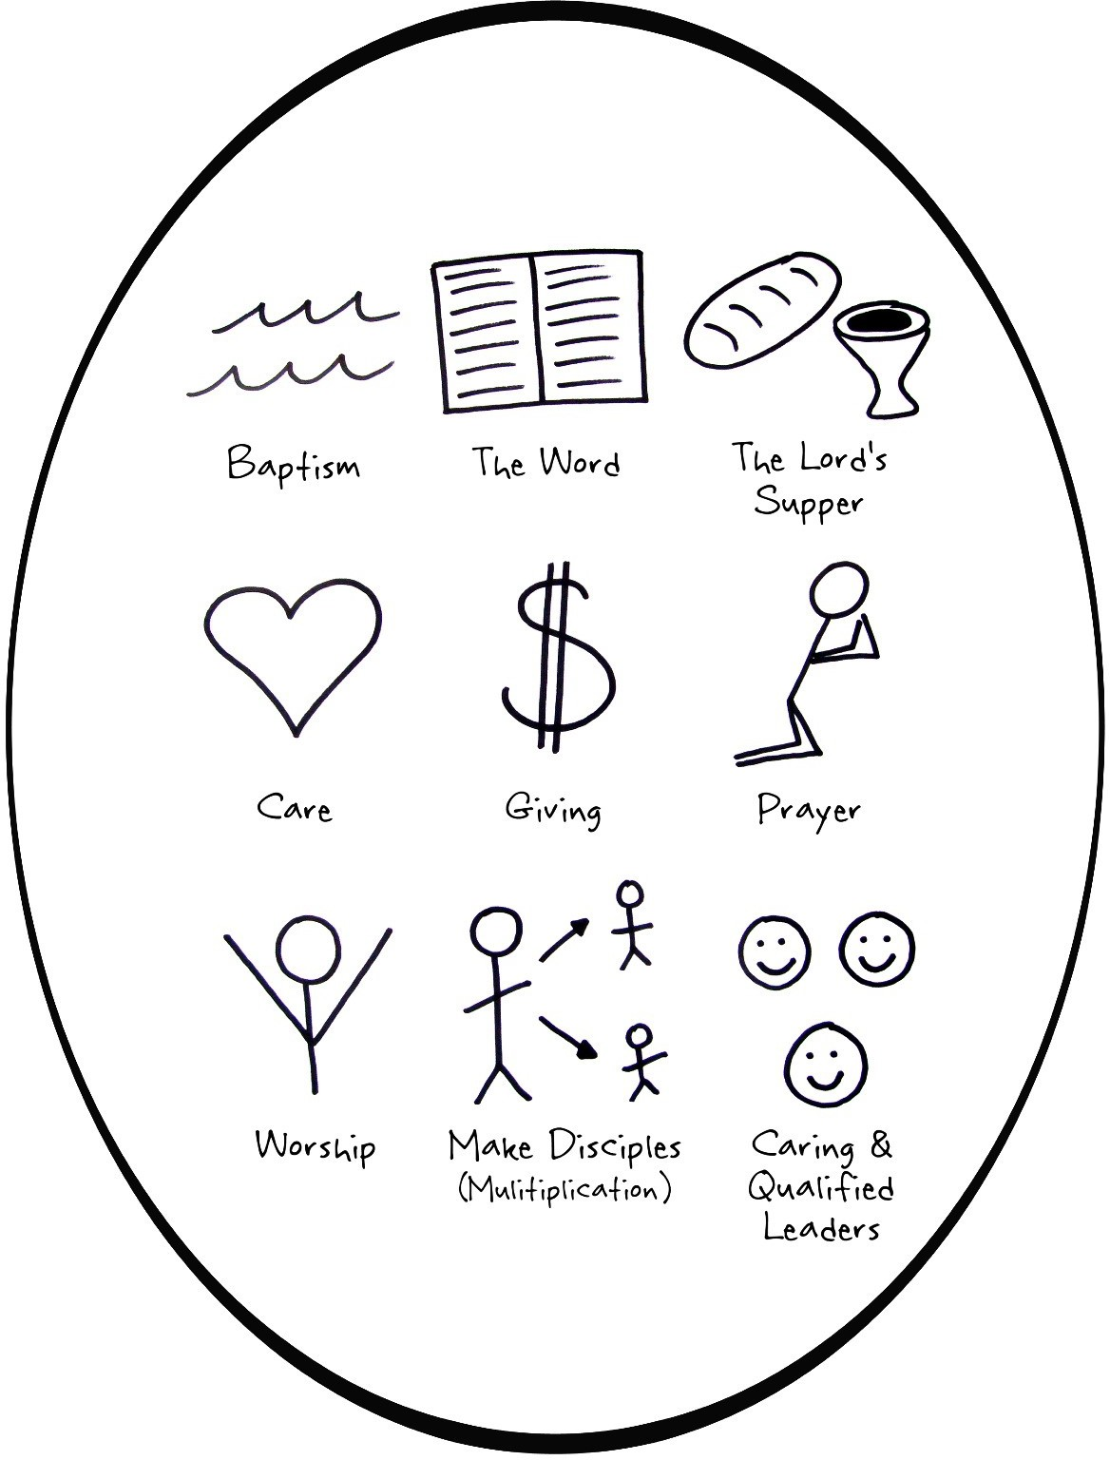

Who is your church? The question is not, "Where do you go to church?" But rather, "Who is your church? Who are you being church with 24/7/365?"
Who is your church? (Discuss this with your partner)

- Understanding Financial Giving: Working with your partner, read 2 Corinthians 9:6-7, then write in your own words what this passage teaches you about giving.
2 Corinthians 9:6-7; “Remember this -- a farmer who plants only a few seeds will get a small crop. But the one who plants generously will get a generous crop. You must each make up your own mind as to how much you should give. Don't give reluctantly or in response to pressure. For God loves the person who gives cheerfully.”

What does the Bible teach about our generous giving?

- Understanding the Lord's Supper: Read the passage below and then answer the questions.
1 Corinthians 11:23–26; For I pass on to you what I received from the Lord himself. On the night when he was betrayed, the Lord Jesus took some bread ²⁴ and gave thanks to God for it. Then he broke it in pieces and said, “This is my body, which is given for you. Do this to remember me.” ²⁵ In the same way, he took the cup of wine after supper, saying, “This cup is the new covenant between God and his people—an agreement confirmed with my blood. Do this to remember me as often as you drink it.” ²⁶ For every time you eat this bread and drink this cup, you are announcing the Lord’s death until he comes again.

What do the elements of the Lord's Supper represent?
Bread =
The body of Jesus which was given for you as a sacrifice for sins.

Wine or Grape Juice =
The blood of Jesus given to you as a new covenant between Yahweh and His people.
What is the expressed purpose of the Lord's Supper?
To remember the Lord’s death as a testimony of His finished work until He returns.

What are the requirements for sharing the Lord's Supper with other Christians? Examine yourselves that you do not take in a vain or unworthy manner.

- Understanding Leadership: Use the STAR method to study and discuss the following passage.
Ephesians 4:11-16; ¹¹ And He Himself gave some to be apostles, some prophets, some evangelists, and some pastors and teachers, ¹² for the equipping of the saints for the work of ministry, for the edifying of the body of Christ, ¹³ till we all come to the unity of the faith and of the knowledge of the Son of God, to a perfect man, to the measure of the stature of the fullness of Christ; ¹⁴ that we should no longer be children, tossed to and fro and carried about with every wind of doctrine, by the trickery of men, in the cunning craftiness of deceitful plotting, ¹⁵ but, speaking the truth in love, may grow up in all things into Him who is the head—Christ— ¹⁶ from whom the whole body, joined and knit together by what every joint supplies, according to the effective working by which every part does its share, causes growth of the body for the edifying of itself in love.

Hebrews 13:17; Obey your spiritual leaders and do what they say. Their work is to watch over your souls, and they are accountable to God. Give them reason to do this with joy and not with sorrow. That would certainly not be for your benefit.

What do these passages say about the leaders?
They are charged with watching out for your souls, to plan for and carry out plans that help you become spiritually mature.

What does this say about your response to your leaders?
Do your part in such a way that brings your leaders joy.

Hebrews 10:24-25; ²⁴ And let us consider one another in order to stir up love and good works, ²⁵ not forsaking the assembling of ourselves together, as is the manner of some, but exhorting one another, and so much the more as you see the Day approaching.

What does this say about your purpose for being a part of a church?
Come together for the purpose of ministering to one another instead of looking to be ministered to. Be considerate of one another (keeping in mind what each one is like and what each one is experiencing in life). Use this knowledge to encourage and provoke one another to love and good works.

LOOKING FOR THE CHURCH WITHIN THE CROWED
5 But whatever house you enter, first say, ‘Peace to this house.’ ⁶ And if a son of peace is there, your peace will rest on it; if not, it will return to you. ⁷ And remain in the same house, eating and drinking such things as they give, for the laborer is worthy of his wages. Do not go from house to house. ⁸ Whatever city you enter, and they receive you, eat such things as are set before you. ⁹ And heal the sick there, and say to them, ‘The kingdom of God has come near to you.’ Luke 10

1) 2)

WHO
… is your mission field?

WHAT

- Your"oikos"(Greekforhousehold) b. Faith Story & the Bridge Immediate&Extended Family;

ClosestFriends
- Friends ; Neighbors;WorkAssociates c."ThirdPlace"
d. Acquaintances

4)

Guide
Partner with the Holy Spirit
- Begin a Discovery Bible Study

Faith in Christ

HOW DO WE 3)

… form & multiply churches?
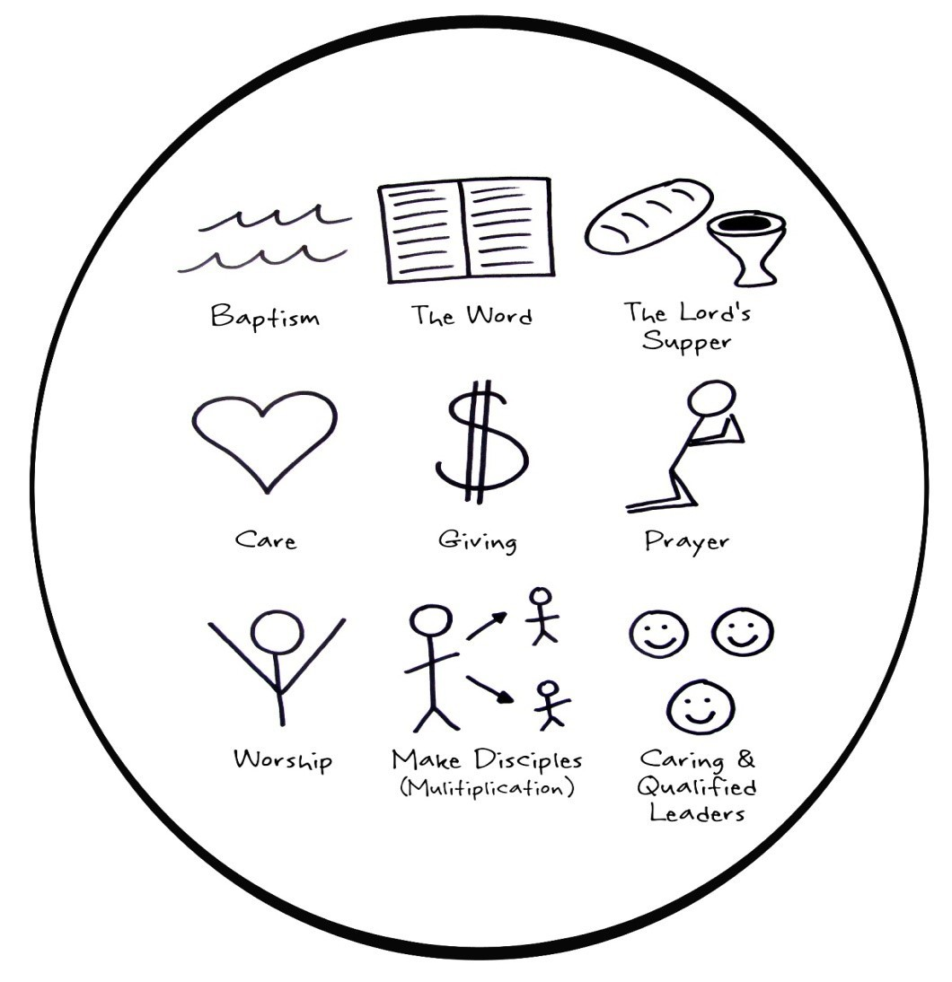
- functionsof church

HOW

  - 8 Short – Term Lessons
  - Long – Term Discipleship







-22-

Trainer’s Guide for Lesson #7
“God: Our Heavenly Father”

Desired Results for Trainees: Objectives are to understand we have a Heavenly Father who loves us, to learn how to discern God’s will through prayer, reading His word, fellowshipping with other believers, and to be held accountable to obey.
First Third of the Lesson—LOOKING BACK

Pastoral Care: Ask the group members how they're doing and let them share anything that's on their hearts. You can do this in the form of a highlight and challenge, but be sure not to make this routine and rigid. As you listen, take time to give counsel from Scriptures, encouragement / comfort / correction, and pray for their situation. If the group is large you may want to break up into smaller groups of two or three. You are modeling how the body cares for its members.

Worship: Read a Psalm or sing some songs to spend some time worshipping together.

Accountability: Continue to remind them of the vision to form generations of trainers.

FOLLOWING
How did you do in obeying what God taught you last week during the training or in your daily Bible reading?

FISHING
Witness: Who are you witnessing to and who has believed?
Starters: When are you training those who have believed? Remind them of their responsibility to train them, not bring them to this training.
Trainers: How are your new believers doing in witnessing and winning others? Trainer of Trainers: When are they training their groups?
Have them draw out their generational growth charts.

Vision-Casting:
In John 4:35, Jesus chided His disciples for missing the harvestable person (the woman at the well). They too had an excuse:

"Do you not say, ‘Four months more and then the harvest’? I tell you, open your eyes and look at the fields! They are ripe for harvest" (John 4:35, NIV84).

In all likelihood, the wheat fields that Jesus was pointing to were green. Each of the disciples knew it would take four more months of maturing before they would be ready to harvest. But Jesus used that physical analogy to describe a heart attitude of the disciples.

While Jesus sat at the well, tired and exhausted from traveling, whom did the disciples pass on the road to the Samaritan village of Sychar? In all likelihood, they passed the immoral woman that Jesus would witness to. They missed her, while Jesus found her. Their circumstances were identical. Twelve found a field unready for harvest while One found a field ready for harvest. The disciples knew that "normally" Samaritans were not ready to believe. But because the Spirit was working in this woman's heart, she was "abnormal!" She broke the norms for how long it takes for people to believe and how quickly they can lead others to faith.

The same is true where we are. We can approach our fields assuming that it will take a certain number of months or years before people are ready to believe. Or we can believe that the fields are ready now. There are abnormal people all around us. The Spirit has already prepared these fields for harvest. Let's go find them!
The only way we find them is by continuing to witness and train abundantly. And we must learn to respond to the inner prompting of the Holy Spirit.

Second Third of the Lesson—LOOKING UP

New Lesson:
Hand out the Worksheet for Lesson #7—God: Our Heavenly Father. Teach the lesson slowly. Encourage the trainers to write down everything including any illustrations or stories you share so they can remember how to use this lesson to train others.

Final Third of the Lesson—LOOKING ONWARD

Practice:
After the lesson, have pairs of trainers practice the lesson including stories and examples until they are confident and competent to share this with others. As they practice, you should wander around the group listening, answering questions, and ensuring that they are doing it correctly.

Now remind the group that they will need to train their new believers just like you have. Therefore, review all three thirds from this week's session so that they can train their new believers using the three thirds, not just the lesson. This is an important point in the training process, so make sure they do not overlook any of the seven parts in the three thirds, especially these parts that get to reproduction:

First Third | Second Third | Final Third
- Pastoral Care  - Worship  - Accountability  - Vision-Casting | - New Lesson | - Practice  - Set Goals & Prayer
LOOKING BACK LOOKING UP LOOKING ONWARD

Set Goals:
  - To gather a few people together to start a group for either Bible study or to be trained.
  - Set a goal to witness to 5 people on their list and to start training anyone who believes.

Close in Prayer

Worksheet #7
“God: Our Heavenly Father”

When a spiritual baby is born, they have new life. We believe Life is about relationships, so the new believer needs to know how to relate to their family (The 3/3rds Discipleship Process; Lesson 1). They need a confidence and trust in their new relationships (Assurance of Eternal Life; Lesson 2). They need to know how to have a conversation with their Father (Prayer; Lesson 3), what it means to obey and the first act of obedience (Baptism; Lesson 4), how to feed themselves and others (Scripture Reading; Lesson 5), and how to have a family life (Church; Lesson 6). But now he needs to know who is in charge of the family: Our Heavenly Father. Jesus taught His disciples to say, "Our Father who art in heaven." The Heavenly Father loves us, protects us, provides for us, leads us, and disciplines or trains us.

The Heavenly Father's Love

"The LORD appeared to us in the past, saying: “I have loved you with an everlasting love; I have drawn you with loving-kindness." Jeremiah 31:3

How does God reveal His love to you?

Romans 5:8; But God demonstrates His own love toward us, in that while we were still sinners, Christ died for us.

1 John 3:1; Behold what manner of love the Father has bestowed on us, that we should be called children of God! Therefore, the world does not know us, because it did not know Him.

Ephesians 2:4-5; But God, who is rich in mercy, because of His great love with which He loved us, ⁵ even when we were dead in trespasses, made us alive together with Christ (by grace you have been saved)…

The Heavenly Father's Protection

"But the Lord is faithful, and he will strengthen and guard you from the evil one." 2 Thessalonians 3:3 What do these Scriptures say about God's protection?
Psalm 4:8; I will both lie down in peace, and sleep; for You alone, O LORD, make me dwell in safety.

Psalm 91:2; I will say of the LORD, “He is my refuge and my fortress; my God, in Him I will trust.”

1 Corinthians 10:13; No temptation has overtaken you except such as is common to man; but God is faithful, who will not allow you to be tempted beyond what you are able, but
with the temptation will also make the way of escape, that you may be able to bear it.

The Heavenly Father's Provision

And my God will supply all your needs according to his glorious riches in Christ Jesus. Philippians 4:19

Why are God’s children not to worry?

Matthew 6:31-32, “Therefore do not worry, saying, ‘What shall we eat?’ or ‘What shall we drink?’ or ‘What shall we wear?’ ³² For after all these things the Gentiles seek. For your heavenly Father knows that you need all these things.

Is God willing to provide for your needs?

Romans 8:32; He who did not spare His own Son, but delivered Him up for us all, how shall He not with Him also freely give us all things?

The Heavenly Father's Leading
Trust in the LORD with all your heart; do not depend on your own understanding. Seek his ways in all you do, and he will show you which path to take. Proverbs 3:5–6
How does God communicate His will for us?

Psalm 119:105; Your word is a lamp to my feet and a light to my path.

1 Thessalonians 4:3; For this is the will of God, your sanctification: that you should abstain from sexual immorality;
1 Thessalonians 5:16-18; ¹⁶ Rejoice always, ¹⁷ pray without ceasing, ¹⁸ in everything give thanks; for this is the will of God in Christ Jesus for you.

The Heavenly Father's Training / Discipline
The Lord chastens those he loves, and he disciplines everyone he accepts as a son.” Hebrews 12:5–6 How does God train His children?
Proverbs 27:17; As iron sharpens iron, so a man sharpens the countenance of his friend.

2 Timothy 3:16; All Scripture is given by inspiration of God, and is profitable for doctrine, for reproof, for correction, for instruction in righteousness.
James 1:2-4; My brethren, count it all joy when you fall into various trials, ³ knowing that the testing of your faith produces patience. ⁴ But let patience have its perfect work, that you may be perfect and complete, lacking nothing.
SUMMARY: Which aspect of the Heavenly Father is most meaningful to you?
His love and kindness
His protection
His provision for your needs
His leading
His training and discipline
Why?

Trainer’s Guide for Lesson #8
“Reaching Your World”
Desired Results for Trainees: Objectives are to develop a vision and a strategy for God to start a movement through the trainees by developing multi-generational groups through the T4T disciple making process and leading people through Discovery Bible Studies.
First Third of the Lesson—LOOKING BACK

Pastoral Care:
Ask the group members how they are doing and let them share anything on their hearts. As you listen, take time to give counsel from Scriptures, encourage / comfort, lovingly exhort / correct, and pray for God's intervention. If the group is large, you may want to have just a few people share. You are modeling how to help the body care for itself through the gifts and members of the body. In subsequent weeks, you may want to do this in smaller, same-sex groups of three or four people. When people share issues that will take more time to address, pray for them immediately but ask them to stay late or meet with you later to help them with these deeper issues.

Worship:
Choose a Scripture, a Psalm, a devotional thought, or sing a song.

Accountability:
Have them draw out their generational charts and explain where they are stuck. Ask specific questions about which lessons they are on in training their new believers.

Vision-Casting:
The Cost of Discipleship. When a person decides to be a disciple of Jesus Christ, in many countries in the world, they face severe persecution. Often this means arrest, torture and even death. In the US the word persecution cannot be used in this sense, but there is a cost to being a disciple. Jesus taught us to count the cost of discipleship in Luke 14:25-33.
The cost of discipleship:
- Spiritual warfare = see Ephesians 6:12
- Time commitment = you can't add disciple-making to your schedule; you will have to intentionally make time in order to be obedient to the Great Commission.
Second Third of the Lesson—LOOKING UP

New Lesson:
Hand out worksheet #8 on "Reaching Your World" and work through all the questions.
Final Third of the Lesson—LOOKING ONWARD

Practice:
Have them practice teaching the new lesson and make sure they understand all 7 parts of the Three Thirds process including the 4 parts that must not be left out.

Set Goals:
Encourage them to commit to gathering again to continue learning to be a disciple-maker. Remember to witness to 5 people on their name list and to start training anyone who believes.

Worksheet #8
“Reaching Your World” THE CALL TO MINISTRY

Read 2 Corinthians 5:16–21 then answer…
16 Therefore, from now on, we regard no one according to the flesh. Even though we have known Christ according to the flesh, yet now we know Him thus no longer. ¹⁷ Therefore, if anyone is in Christ, he is a new creation; old things have passed away; behold, all things have become new. ¹⁸ Now all things are of God, who has reconciled us to Himself through Jesus Christ, and has given us the ministry of reconciliation, ¹⁹ that is, that God was in Christ reconciling the world to Himself, not imputing their trespasses to them, and has committed to us the word of reconciliation.
20 Now then, we are ambassadors for Christ, as though God were pleading through us: we implore you on Christ’s behalf, be reconciled to God. ²¹ For He made Him who knew no sin to be sin for us, that we might become the righteousness of God in Him.

- When you came to Christ you were given a new life with the ability to look at others the way God sees them. We became friends to God and were given the ministry to make more friends for God. We were assigned to be ambassadors of Yahweh and the kingdom of Heaven.

- To accomplish this God made Jesus (who knew no sin) to be sin for us and advanced us the righteousness of God through Jesus.

- What does it mean “we are Christ’s ambassadors”? What is our role as ambassadors?

We serve as representatives of Yahweh between the Kingdom of God and the people of this present world. It is our job to help people make peace with God and express God’s good will toward them.

THE STRATEGY OF MINISTRY

- Read 2 Timothy 2:2. Starting with Paul, how many “spiritual generations” do you see illustrated? Write them out:

What we receive in training we pass on to faithful people who will in turn pass it on to other faithful people. It is good to help a trainee to teach a lesson to a new trainee as soon as possible. We are looking to create generations of trainers, trainer others who will train even more.

- A plan to reach your world: "Ask yourself, ‘How many of my people will hear the Gospel today?’"

Step 1. Understanding Your World ("Your Mission")
TEN MOST WANTED
The following list of 10 people are who I would most like to see come into a transforming relationship with Jesus Christ. I will pray for these people, share my faith story with them, be willing to disciple them, and expectantly believe they will become disciples who make disciples.

YOUR NAME:

DATE:

1.

2.

3.

4.

5.

6.

7.

8.

9.

10.

Take a few minutes to prayerfully complete your "10 Most Wanted" list
è
How many people far from God are in each of these categories?

  - My "oikos"

    - My neighborhood

  - My work place

    - My "third place"

("third place" is somewhere you spend significant time besides home or work, and have acquaintances & friends)

Where will you start?

What will your "next steps" be?

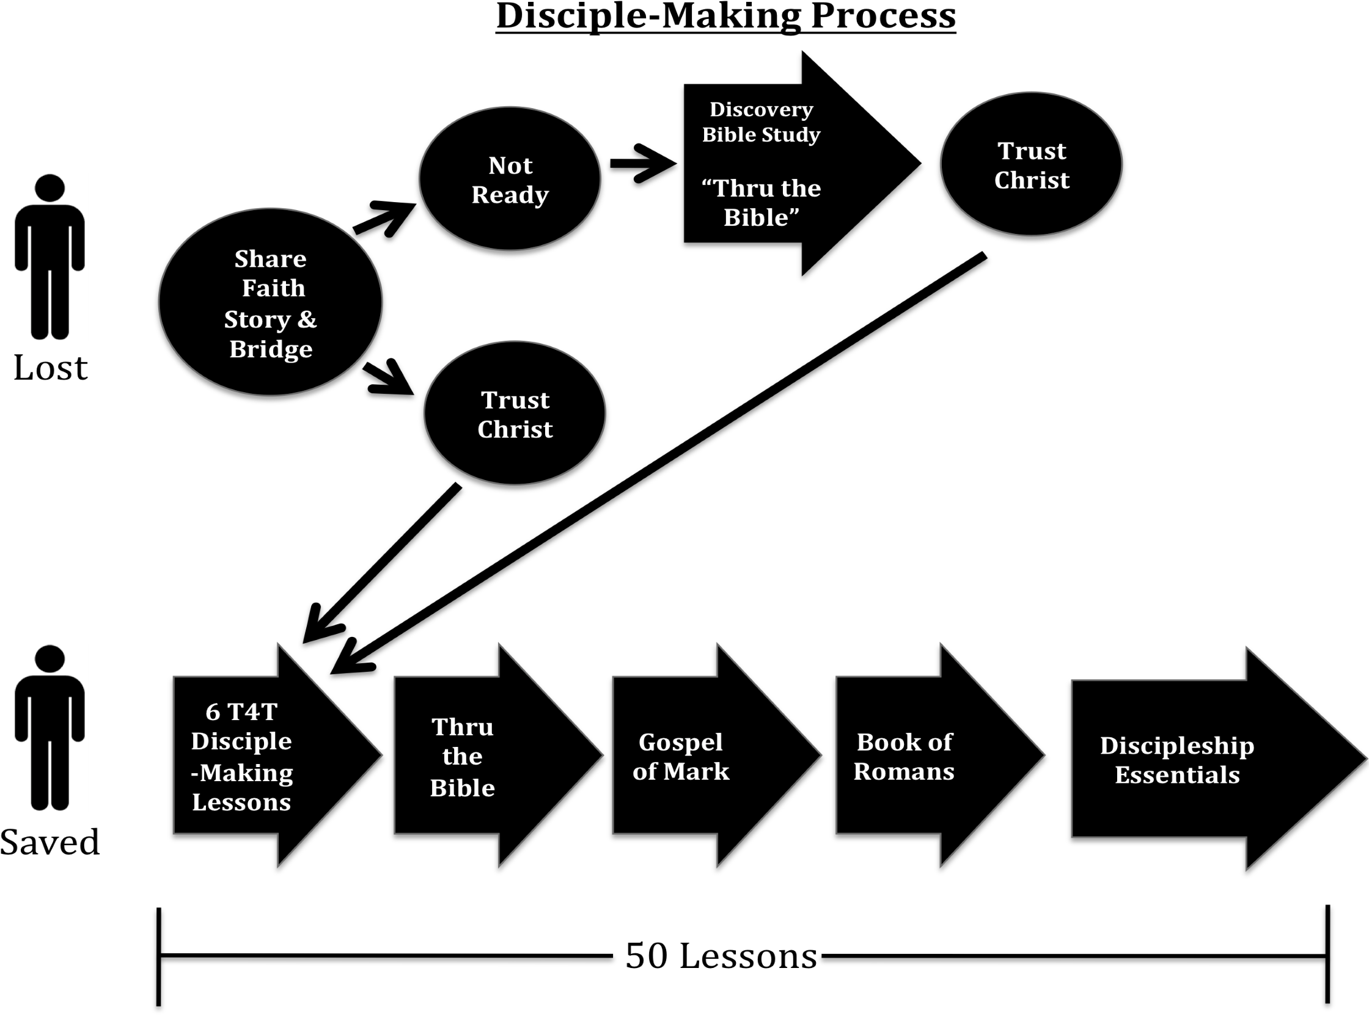
8

DISCOVERY BIBLE STUDY

Ed Stetzer in his book Lost and Found presented the results of a survey he conducted in which people were asked to respond to the statement: "I would be willing to study the Bible if a friend asked me to." Sixty-one percent of those surveyed answered "Yes." People are interested in learning more about the bestselling book of all time—the Bible. Invite them into an 8-week study that will provide them with an overview of the entire Bible.

Thru the Bible Inductive Discovery Bible Study allows people (either saved or lost) to examine the truths of God's Word in a self-discovering way. Using the three-thirds process of T4T, this study provides an overview of the Old and New Testaments by using three different methods of Inductive Bible study.

In Thru the Bible 4 Old Testament and 4 New Testament chapters are examined:
- Genesis 3 (The Fall) •John 1 (Identity of Jesus)
- Exodus 20 (Ten Commandments) •Matthew 27-28 (Death, Resurrection, Great Commission)
- Psalm 103 (Faithful Love of God) •Romans 8 (Victorious Christian Living)
- Isaiah 53 (The Suffering Messiah) •Revelation 20 (Final Judgment)

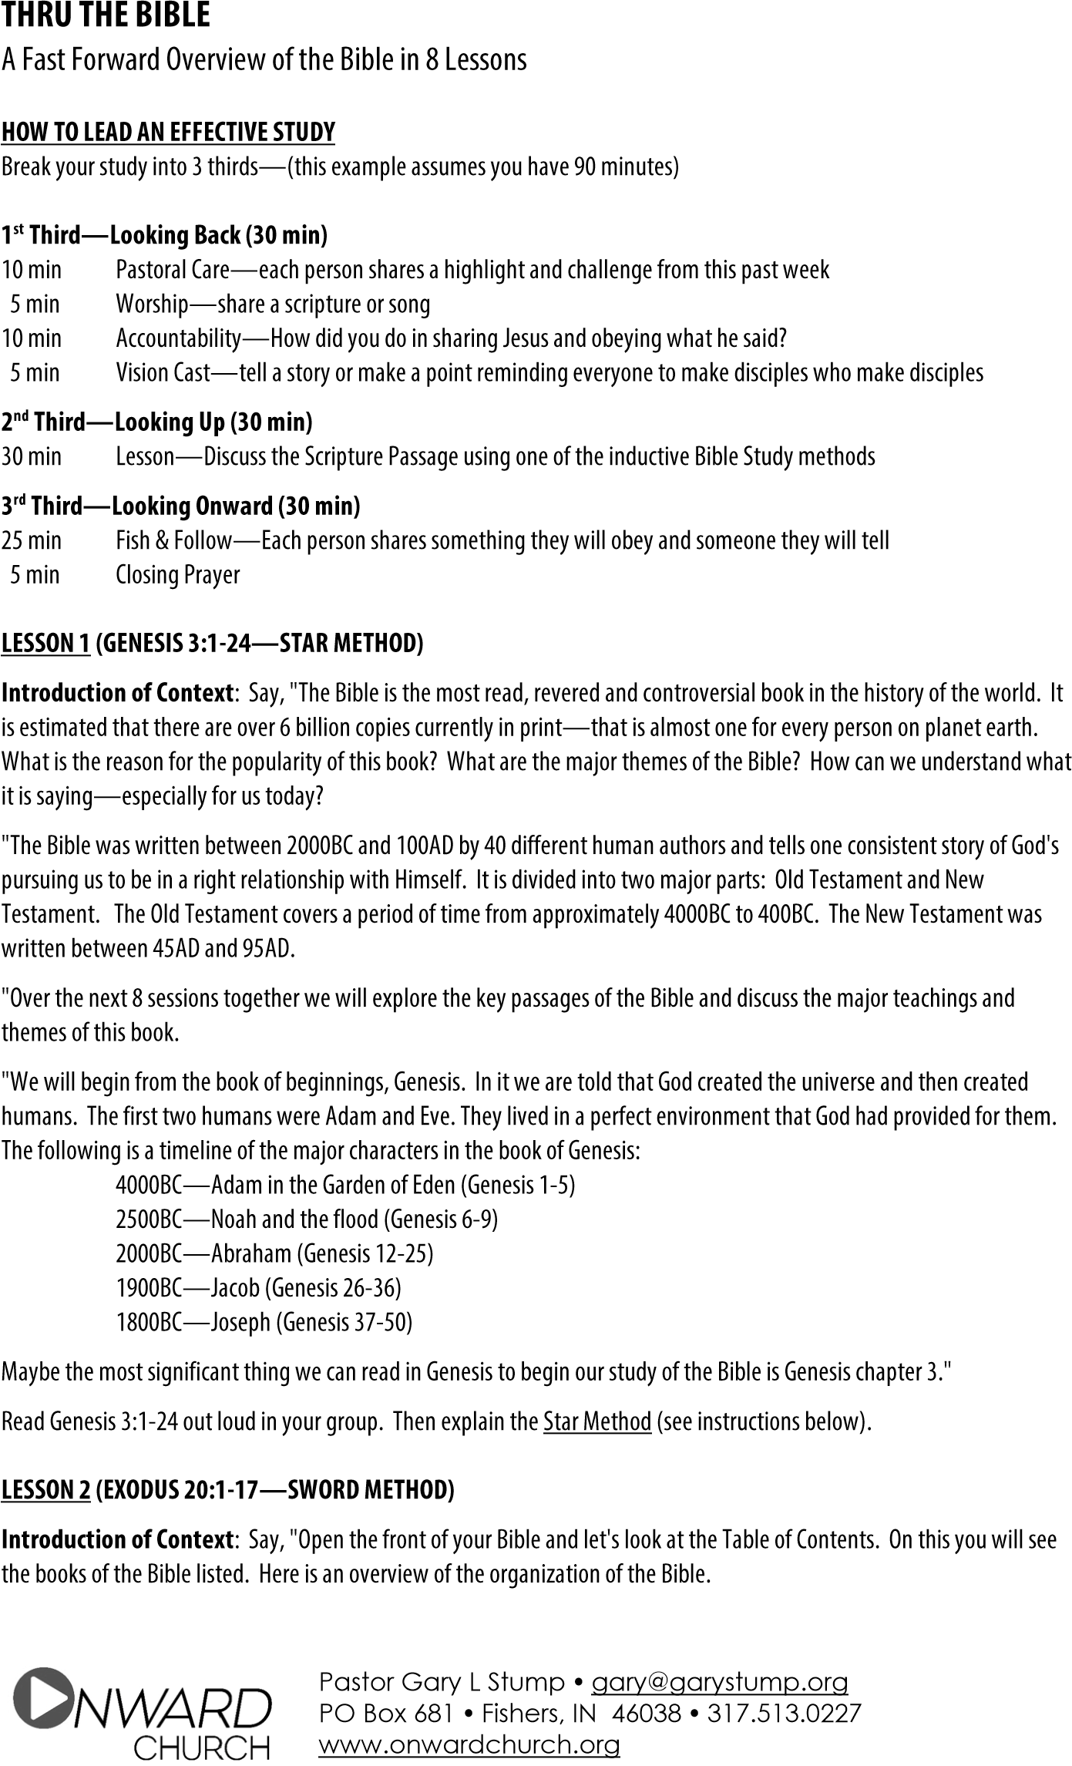


Pastor Brian Holland • 770-884-1496 • brian@phoenixatl.org Pastor Jackie Fendley • 678-477-6560 • jackson@phoenixroasters.coffee

Genesis, Exodus, Leviticus, Numbers, and Deuteronomy; these books are called “The Law” and were written by Moses. They cover the time from creation through 1,400BC when the “Children of Israel” were poised to enter “The Promised Land” of Canaan; basically, modern Israel. Moses formalized the way people approached God in worship through the system of animal sacrifices.
Joshua to Ester; the next 12 books detail the history of Israel from the Promised Land under the leadership of Joshua until 400BC which coincides with the end of the Old Testament.
Job, Psalms, Proverbs, Ecclesiastes and Song of Solomon; these books were written in Hebrew poetry and give wisdom from God and praises to God.
Isaiah, Jeremiah, Lamentations, Ezekiel, and Daniel; these books are called the Major Prophets, not because what they said was more important, but because the books are so extensive. They cover a crucial time in Israel’s history (700 to 530BC) when God was declaring both His consequences for their sin and His future salvation because of His love.
Hosea to Malachi; these 12 books re called the Minor Prophets and cover the time between 800BC and 400BC. Malachi was the last prophet in the Old Testament and declared that the next prophet would “prepare the way for the Lord’s arrival on earth.”
At the end of Genesis, the children of Israel moved to Egypt until ultimately 400 years passed, and the Egyptians had enslaved them. God sent Moses to Pharaoh to demand that they would release the Israelites from slavery so they could enter the “Promised Land.” During Pharaoh’s refusal 10 different plagues afflicted the Egyptians until the final plague, death of the firstborn, caused him to release the Jews. The Israelites were saved from death through the institution of the Passover. Moses led them into the wilderness and to Mount Sinai where he received the inscribed tablets from God. We call this, The Ten Commandments. Let’s turn to Exodus 20 and discover this together. Read Exodus 20:1-17 using the SWORD METHOD to discuss this chapter (see instruction below).

LESSON 3 (PSALM 103:1-22 – STAR METHOD)
Introduction of Context; say, “After the Children of Israel entered the Promised Land, they experienced a time of prosperity. This prosperity caused them to forget to worship God which brought on great times of struggles as God disciplined them for their disobedience. God appointed representatives led the nation until people requested a king. God selected Saul as their first king and David as the second king (c.1000BC). King David was called a man after God’s own heart and he led the nation to follow the Lord. David wrote many songs (called Psalms) that praised God for his loving care for His people. Today we will look at one of his songs of praise.
Turn in your Bible to Psalm 103. There are many people who think God in the Old Testament is judgmental, while God in the New Testament is more loving and kinder. So, let’s read this Psalm to better understand the eternal character and nature of God.”
Read Psalm 103:1-22; use the Star Method to discuss this passage.

LESSON 4 (ISAIAH 53:1-12 – STEPHEN METHOD)
Introduction of Context; say, “Through the Old Testament God was moving toward the time when He would send a Redeemer into the world to provide the ultimate sacrifice for our sin. From immediately after the first sin (remember Genesis 3), when God promised His Redeemer, all of the sacrifices had been a representation of the coming Messiah. The Law, the books of history, the books of poetry, and the “prophets” all looked forward to this future savior. To summarize the books of prophecy we can read Isaiah 53 written about 700 years before Christ.”
Read Isaiah 53:1-12 out loud. Use the STEPHEN METHOD to discuss this passage (see instructions below)

LESSON 5 (JOHN 1:1-34 – STEPHEN METHOD)
Introduction of Context; say, “Today we welcome you to the New Testament. Turn to the Table of Contents in your Bible and let’s see how the New Testament is made up. The first four books are called Gospels. These are written to tell the story of Jesus for the purpose that people would believe in Him and have Eternal Life. Next is the book of Acts which tells the story of the early church for about 30 years after Jesus’ death and resurrection. Then there are 13 books or letters (Romans thru Philemon) written by the Apostle Paul to churches and people to encourage them how to live as Christians. The next 8 letters were written by various writers to Christians everywhere, especially Jews, who were scattered around the world because of persecution. The last book is Revelation and describes the end times and the return of Christ to establish His kingdom on earth.
‘For 400 years there had not been a prophet in Israel. God remained true His promise until it was time Jesus to be born in Bethlehem to a virgin named Mary, and her fiance´, Joseph. Jesus is the single most influential person who has ever lived, yet He never more than a few dozen miles from home. He didn’t write any books or hold any political office. He only ministered for about 3 years and His legacy still impacts billions of people some 2000 years later. How can this be? Today we will consider what the Bible says about Him. Let’s turn to John 1.”
Read John 1:1-34. Use the STEPHEN METHOD to discuss this passage.

LESSON 6 (MATTHEW 27:45-28:20 – STEPHEN METHOD)
Introduction of Context; say, “Jesus began His ministry after He was baptized by John. He taught a new way of living in God’s kingdom summarizing all the commandments with ‘love God with all your heart, soul, mind, and strength, and love your neighbor as yourself.’ He performed many miracles. He walked on water, turned water into wine, fed 5000, healed the sick, cast out demons and even raised the dead. Even those who opposed him could not dispute His miracles. But more importantly, He continually reminded people that His mission was to suffer for the sins of all people and then rise form the dead. Today let’s look at the most significant event in human history, the death and resurrection of Jesus Christ. At about 9AM they nailed Jesus to the cross. Let’s pick up the story from there…turn in your Bible to Matthew 27:45.”
Read Matthew 27:45-28:20. Use the STEPHEN METHOD to lead a discussion of this passage.

LESSON 7 (ROMANS 8:1-39 – STAR METHOD)
Introduction of Context; say, “After Jesus raised from the dead, he showed Himself to hundreds of people and was observed for 40 days. Then He was taken into heaven with a promise to return. Ten days later the church begins as Peter preached about Jesus’ death and resurrection. The message of the good news about God’s salvation through Jesus was proclaimed throughout the known world. Tens of thousands of people responded by following Christ. One of the important leaders of the church was a former Jewish leader who became the Apostle Paul. He wrote many letters of the Christian churches all over the world. One of the great letters he wrote was the letter to the Romans. Chapter 8 of this letter is one of the most important passages in the Bible. Today we will look at this amazing chapter.”
Turn in your Bibles to Romans 8:1-39. Use the STAR METHOD to discuss this passage.

LESSON 8 (REVELATION 20:1-15 – SWORD METHOD)
Introduction: say, “As people herd the good news about eternal life through faith in Jesus, tens of thousands believed and were gathered into churches all over the known world. Many of the books of the New Testament provide guidance for Christian living. But when Jesus was taken into heaven, He promised to return again and establish His kingdom on earth. His return means that the world will experience peace and justice and His benevolent rule as King of Kings. There are many events that will happen but will culminate with Jesus’ return. We can read about this in Revelation 20.”
Turn in your Bibles to Revelation 20. – Use the SWORD METHOD to discuss this passage.

STAR METHOD

- First, read the passage aloud. (Can take turns if in a group).

BIBLE STUDY METHODS

- Each person then reads over the passage on their own and look for these 3 things:
  - Anything that stands out or draws their attention as important Mark with a STAR ().
  - Anything that the reader finds hard to understand or has a question about Mark with a QUESTION MARK (?)
  - Anything that applies personally to the reader’s life or that they feel directs them to do something
Mark with an ARROW ( ➔ ).
- Each person should try to write down at least one thing, but not more than three for each category.
- Each person should then share things they have marked with a Star and discuss them with the group. Everyone shares all their Stars first before you move on to the Question Marks.
- Each person should share things they have marked with a Question Mark and the group should try to work out answers for each. A core value is to never answer questions unless you know the answer. A perfectly acceptable answer is, “I don’t know, but I will look into this and see what we find out for the next time.”
- Each person should then share things they have marked with an Arrow and discuss them with the group. Finish by each person sharing a “Fish & Follow” action step. Write an “I will” statement that describes specifically what you will do as a result of this study (something to obey = follow); and someone with whom to share their story (someone to tell = fish).

SWORD METHOD


After reading the passage out loud lead a discussion using these 5 questions:

- What does this Scripture say about God?

- Is there a sin to avoid?
- Is there a promise to claim?

- What does this Scripture say about me?

- What am I going to do?

The Word of God is often likened to a sword (“For the Word of God is living and active, sharper than any double-edged sword,” Hebrews 4:12

STEVEN METHOD
After reading the passage out loud lead a discussion using these 5 questions:
- What did you like about this passage?
- What is something in the passage that bothered you or left you confused?
- Based on this Scripture what can you say is true about people?
- Based on this passage what is true about God?
- What do you need to do in response to this this story? (Something to obey; someone to tell)

Leaders Guide for GOSPEL OF MARK—T4T Discovery Bible Study in 8 Lessons
Lesson | Scripture  Passage | Additional Discussion Questions
1 | Mark 1:1-15  Jesus Baptized | - How does Mark show us that Jesus is worthy of attention?  - What “witnesses” does Mark call upon to introduce Jesus, and why?  - What is meant by "repent," "believe," and "baptized?"  - What implications does Jesus’ experience of temptation have for the temptations we face?  - What steps could you take this week to encourage other Christians to be better  witnesses for Christ?
2 | Mark 2:1-12  Jesus Heals Paralyzed Man | - What do the details of this story tell you about the paralytic man, his friends, and  - Jesus’ reputation?  If someone in a crowd of people said to you, “Your sins are forgiven”, what  - would you and everyone else think of that person?  - How does Jesus demonstrate his claim to be able to forgive sin?  Which is easier for you to do—forgive others or care for them when they are sick?  - Following the example of the paralytic man’s friends, how could you go out of your way this week to help another believer who is experiencing pain or  suffering?
3 | Mark 3:7-35 Jesus chooses Disciples & sends them out;  answers critics | - What was unusual about the crowds that came to see Jesus?  - What responses to Jesus do you see in this passage?  - Why was Jesus’ authoritative teaching a threat to the teachers of the law?  - When, if ever, have you been thought of as “out of your mind” by other people because of your efforts to live a Christian life?  - According to this passage, how do you become a part of Jesus’ family  - What can you do this week that will restore a relationship that strains your unity with other Christians?
4 | Mark 8:22-38  Jesus heals blind man; identifies himself | - What event takes place just before Peter’s confession? Why do you think these two stories are placed next to each other?  - What do we learn about Jesus’ character from the way He treated the blind man?  - What did Jesus tell his disciples to do if they wanted to follow Him?  - According to Jesus, why does a follower of Christ have to “deny himself” and  - “lose his life”?  What specific steps can you take to listen closely to Christ this week?
5 | Mark 10:17-45  Jesus & Rich Man | - According to verses 17-22, what would Jesus say is the basic character of people  - in the world today?  - How did Jesus explain the way to inherit eternal life?  - In verses 32-34, Jesus says that he is going to die. According to verse 45, what is the purpose of his death?  Read Isaiah 53:5, 10-12. How do these verses help us understand what a ransom is?  - What is one distraction you can set aside this week to help you concentrate more on devotion to Christ?

6 | Mark 14:5315:15  Jesus' Arrest & Trial | - Why did the Sanhedrin have such a difficult time convicting Jesus?  - How are some of the characters in this passage similar to each other? How are  - they different?  - What evidence is Mark presenting in his attempt to prove that Jesus is the Christ,  - the Son of God?  How does Jesus’ silence actually communicate his identity? (See Isaiah 53:7-9) What is one step you can take this week to strengthen your conviction against pressure from co-workers, family or friends?
7 | Mark 15:16-39  Jesus Crucified | - How many times does the phrase “King of the Jews” appear in Chapter 15? What is ironic about this? What is Mark trying to say about the events at the  - cross?  - Read Psalm 22. How does this help you understand the words of Jesus from the cross in verse 34?  How does Psalm 22 end? What is Jesus ultimately claiming for himself?  - Why do you think the events at the cross were necessary?  - What final description of Jesus’ identity does Mark provide? Where have you seen this title before?  - What should be your response if you are criticized for your faith this week?
8 | Mark 15:42-16:8  Jesus Raised from the dead | - Of what fact does Mark want his readers to be sure of in verses 42-47?  - What does Mark say happened to Jesus’ body?  - What do Joseph’s actions tell us about his own understanding of Jesus?  - Why is it significant that Jesus rose from the dead?  - What do you see as your personal role in helping spread the news about Christ?

Additional Help and Tools:
  - Use more than one Bible version (i.e. New Living Translation, English Standard Version, New international Version). By comparing different versions, often a question is answered.
  - ESV Study Bible: The notes can help you understand various Bible issues and provide additional information.
  - Sacred Sixty Six Bible Overview by Gary Stump; Onward Church
  - https://www.ehlc.org/s/Thru-the-Bible-2018.pdf

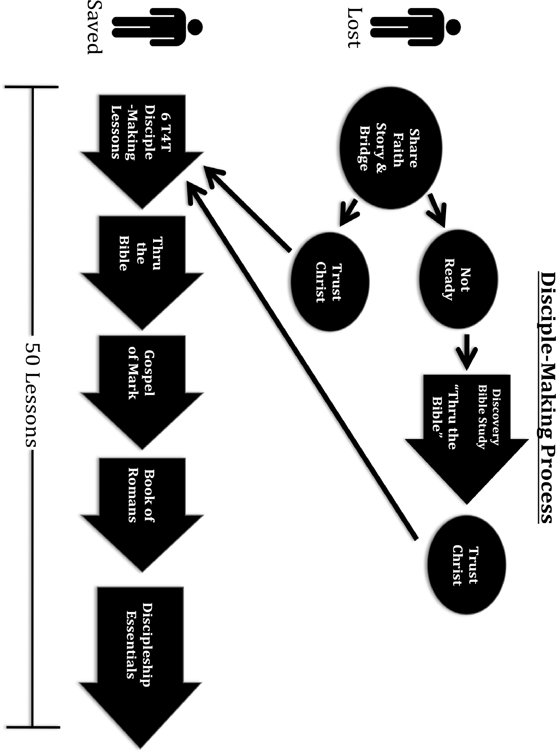
8

TEN MOST WANTED
The following list of 10 people are who I would most like to see come into a transforming relationship with Jesus Christ. I will pray for these people, share my faith story with them, be willing to disciple them, and expectantly believe they will become disciples who make disciples.

YOUR NAME:
DATE:

TEN MOST WANTED
The following list of 10 people are who I would most like to see come into a transforming relationship with Jesus Christ. I will pray for these people, share my faith story with them, be willing to disciple them, and expectantly believe they will become disciples who make disciples.

YOUR NAME:
DATE:

1. 1.

2. 2.

3. 3.

4. 4.

5. 5.

6. 6.

7. 7.

8. 8.

9. 9.

10. 10.

TEN MOST WANTED
The following list of 10 people are who I would most like to see come into a transforming relationship with Jesus Christ. I will pray for these people, share my faith story with them, be willing to disciple them, and expectantly believe they will become disciples who make disciples.

YOUR NAME: DATE: 1.
2.

TEN MOST WANTED
The following list of 10 people are who I would most like to see come into a transforming relationship with Jesus Christ. I will pray for these people, share my faith story with them, be willing to disciple them, and expectantly believe they will become disciples who make disciples.

YOUR NAME: DATE: 1.
2.

3.

4.

5.

6.

7.

8.

9.

10.

